**Supervised Learning**

Supervised learning is the types of machine learning in which machines are trained using well "labelled" training data, and on basis of that data, machines predict the output. The labelled data means some input data is already tagged with the correct output.

In supervised learning, the training data provided to the machines work as the supervisor that teaches the machines to predict the output correctly. It applies the same concept as a student learns in the supervision of the teacher.

Supervised learning is a process of providing input data as well as correct output data to the machine learning model. The aim of a supervised learning algorithm is to **find a mapping function to map the input variable(x) with the output variable(y).**

In the real-world, supervised learning can be used for **Risk Assessment, Image classification, Fraud Detection, spam filtering,** etc.

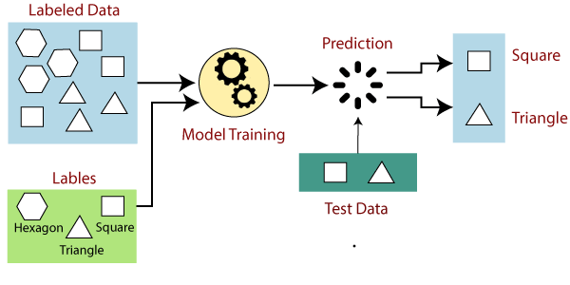

**Types of supervised Machine learning Algorithms:**

Supervised learning can be further divided into two types of problems:

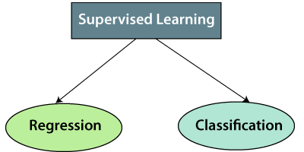

**1. Regression**

Regression algorithms are used if there is a relationship between the input variable and the output variable. It is used for the prediction of continuous variables, such as Weather forecasting, Market Trends, etc. Below are some popular Regression algorithms which come under supervised learning:

* Linear Regression
* Regression Trees
* Non-Linear Regression
* Bayesian Linear Regression
* Polynomial Regression

**2. Classification**

Classification algorithms are used when the output variable is categorical, which means there are two classes such as Yes-No, Male-Female, True-false, etc.

Spam Filtering,

* Random Forest
* Decision Trees
* Logistic Regression
* Support vector Machines

**Unsupervised Learning**

As the name suggests, unsupervised learning is a machine learning technique in which models are not supervised using training dataset. Instead, models itself find the hidden patterns and insights from the given data. It can be compared to learning which takes place in the human brain while learning new things.

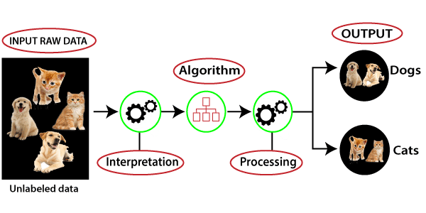

Unsupervised learning cannot be directly applied to a regression or classification problem because unlike supervised learning, we have the input data but no corresponding output data. The goal of unsupervised learning is to **find the underlying structure of dataset, group that data according to similarities, and represent that dataset in a compressed format.**

**Example:** Suppose the unsupervised learning algorithm is given an input dataset containing images of different types of cats and dogs. The algorithm is never trained upon the given dataset, which means it does not have any idea about the features of the dataset. The task of the unsupervised learning algorithm is to identify the image features on their own. Unsupervised learning algorithm will perform this task by clustering the image dataset into the groups according to similarities between images.

**Types of Unsupervised Learning Algorithm:**

The unsupervised learning algorithm can be further categorized into two types of problems:

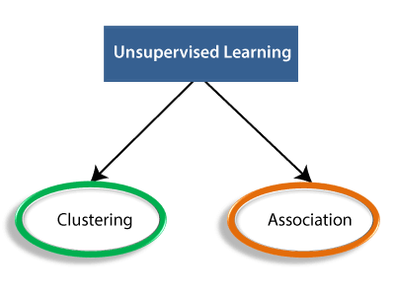

* **Clustering**: Clustering is a method of grouping the objects into clusters such that objects with most similarities remains into a group and has less or no similarities with the objects of another group. Cluster analysis finds the commonalities between the data objects and categorizes them as per the presence and absence of those commonalities.
* **Association**: An association rule is an unsupervised learning method which is used for finding the relationships between variables in the large database. It determines the set of items that occurs together in the dataset. Association rule makes marketing strategy more effective. Such as people who buy X item (suppose a bread) are also tend to purchase Y (Butter/Jam) item. A typical example of Association rule is Market Basket Analysis.

**Self-Supervised Learning**

Self-Supervised Learning (SSL) is a Machine Learning paradigm where a model, when fed with unstructured data as input, generates data labels automatically, which are further used in subsequent iterations as ground truths.

The fundamental idea for self-supervised learning is to generate supervisory signals by making sense of the unlabeled data provided to it in an unsupervised fashion on the first iteration. Then, the model uses the high confidence data labels among those generated to train the model in the next iterations like any other supervised learning model via [back propagation](https://www.v7labs.com/definitions/backpropagation). The only difference is, the data labels used as ground truths in every iteration are changed. It’s most widely used for solving computer vision problems such as [image classification](https://www.v7labs.com/blog/image-classification-guide), [object detection](https://www.v7labs.com/blog/object-detection-guide), [semantic segmentation](https://www.v7labs.com/blog/semantic-segmentation-guide), or [instance segmentation.](https://www.v7labs.com/blog/instance-segmentation-guide)

### **Types of data used in self-supervised learning**

Any machine learning including self-supervised learning involves two types of data.

1. **Positive data:**Data which is the objective of the algorithm.
2. **Negative data:**Data which is nonessential in the eye of an algorithm.

For example, the algorithm has a task to identify the traffic signs in an image grid. All the traffic signs shown in it are positive data, while the rest of images are the negative data. This example might have brought ‘prove that you are not a robot’ question in your mind. That selection game is itself an example of SSL.

### **What are the types of self-supervised learning?**

Self-supervised learning is classified into two major types, Contrastive and Non-contrastive. Here is the brief description of both the types.

#### **Contrastive self-supervised learning**

Contrastive learning methods use both types of data i.e., positive and negative data. There are two main functions of this learning.

* To reduce the distance between positive data to minimum.
* To increase the distance between negative data to maximum.

#### **Non-contrastive self-supervised learning**

Non-contrastive learning methods use only positive data. This learning congregates on a useful local minimum. It doesn’t focus on reaching the expected identity function with zero loss.

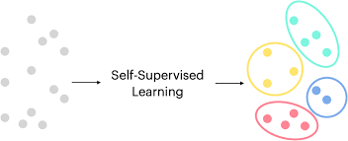

**Reinforcement Learning**

* Reinforcement Learning is a feedback-based Machine learning technique in which an agent learns to behave in an environment by performing the actions and seeing the results of actions. For each good action, the agent gets positive feedback, and for each bad action, the agent gets negative feedback or penalty.
* In Reinforcement Learning, the agent learns automatically using feedbacks without any labeled data, unlike [supervised learning.](https://www.javatpoint.com/supervised-machine-learning)
* Since there is no labeled data, so the agent is bound to learn by its experience only.
* RL solves a specific type of problem where decision making is sequential, and the goal is long-term, such as game-playing, robotics, etc.
* The agent interacts with the environment and explores it by itself. The primary goal of an agent in reinforcement learning is to improve the performance by getting the maximum positive rewards.
* The agent learns with the process of hit and trial, and based on the experience, it learns to perform the task in a better way. Hence, we can say that "Reinforcement learning is a type of machine learning method where an intelligent agent (computer program) interacts with the environment and learns to act within that." How a Robotic dog learns the movement of his arms is an example of Reinforcement learning.
* It is a core part of [Artificial intelligence](https://www.javatpoint.com/artificial-intelligence-tutorial), and all [AI agent](https://www.javatpoint.com/agents-in-ai) works on the concept of reinforcement learning. Here we do not need to pre-program the agent, as it learns from its own experience without any human intervention.

**Types of Reinforcement:**

There are two types of Reinforcement:

1. **Positive:** Positive Reinforcement is defined as when an event, occurs due to a particular behavior, increases the strength and the frequency of the behavior. In other words, it has a positive effect on behavior.

Advantages of reinforcement learning are:

* + Maximizes Performance
  + Sustain Change for a long period of time
  + Too much Reinforcement can lead to an overload of states which can diminish the results

1. **Negative:** Negative Reinforcement is defined as strengthening of behavior because a negative condition is stopped or avoided.   
   Advantages of reinforcement learning:
   * Increases Behavior
   * Provide defiance to a minimum standard of performance
   * It Only provides enough to meet up the minimum behavior

### **Elements of Reinforcement Learning**

  Reinforcement learning elements are as follows:

1. Policy
2. Reward function
3. Value function
4. Model of the environment

**Policy:** Policy defines the learning agent behavior for given time period. It is a mapping from perceived states of the environment to actions to be taken when in those states.

**Reward function:** Reward function is used to define a goal in a reinforcement learning problem. A reward function is a function that provides a numerical score based on the state of the environment

**Value function:**Value functions specify what is good in the long run. The value of a state is the total amount of reward an agent can expect to accumulate over the future, starting from that state.

**Model of the environment:** Models are used for planning.

